Parallel Sorting Algoithms On Hybrid Hetrogeneous Servers
Table of Contents
Abstract 1
Introduction 1
Related Work 1
Architecture Specifications 1
Multithreaded Cores and Multicore CPUs 1
GPUs 1
Cuda Device Archiecture 2
Threads, Blocks and Warps 2
Shared Memory 2
Programming Models 2
OpenMP 2
OpenACC 2
OpenH 2
Cuda 2
Sorting Algorithms 2
Merge Sort 2
Merging 3
Other 3
Measuring Performance 3
Conclusions 3

Abstract
Sorting is one of the fundamental algorithms in computer science used in almost any area of area of computing with a large amount of data points or elements. Efficient sorting algorithms are becoming increasinly important as the size and scale of data continues to grow.
Hybrid hetrogeneous servers featuing multicore CPUs hosting multiple accelerators (GPUs or FPGAs) dominate the comuting landscape due to their ability to efficiently handle very large inputs by performing multiple operations at once.
Because of their importance, efficent sorting algorithms have been the subject of many computer computer science research. Even with these efficient algorithms, sorting large data is still time consuming and benefits from parallel execution. Parallelizing efficient sorting algorithms is challenging and requires efficient design.

Introduction
asdasd

Related Work
Programming Massively Parallel Processors

Architecture Specifications
asasdasd

Multithreaded Cores and Multicore CPUs
Multithreaded and multicore CPUs both exploit concurency by executing multiple threads, although their design target different objectives. Multithreaded CPUs support concurent thread execution at the more fine-grained instruction level aiming at better utilizing the resources of CPUs by issuing instructions from multiple threads. Multicore CPUs achieve thread concurency at a higher level, focusing less on utilization per core and aiming at scailability via replicating cores.[1]

GPUs
The modern GPU has evolved from a fixed function graphics pipeline to programmable parallel processor with computing power exceeding that of multicore CPUs.
With NVIDIA’s Tesla architecture introduced in 2006 in the GeForce 8800 enabled high performance parallel computing applications written in the C programming language using the Computer Unified Device Architecture (CUDA) parallel programming model and development tools. [2]

Cuda Device Archiecture
asdasd

Threads, Blocks and Warps
To manage and execute hundreds of threads running several different programs efficiently, GPUs use a process architecture called single instruction multiple threads (SIMT). The SM’s SIMT multithreaded instruction unit creates, manages, schedules and executes threads in groups of 32 parallel threads called warps.

Shared Memory
To support computing and C/C++ language needs the Tesla SM implements memory load/store instructions with three read/write memory spaces.
- local memory: for per thread, private temporary data (implemented in externel DRAM)
- shared memory: for low latency access to data shared by cooperating threads in the same SM.
- global memory: for data shared by all threads of a computing application (implemented in externel DRAM)
Shared memory is located on chip and as a result has a much higher bandwidth and lower latency than local and global memory. Shared memory enables cooperation between threads in a block, when multiple threads in a block use the same data from global memory, shared memory can also be used to access data from global memory only once.
Shared memory is only accessible by threads within the same block, this can become a problem when sorting large inputs that are greater than the size of a block.[3] Currently Tesla GPUs only support block sizes up to 1024.

Programming Models
asdasd

OpenMP
OpenMP is a parallel programming model for shared memory and distributed shared memory multiprocessors. It is comprised of a set of compiler directives that describe the parallelisms in the source code, along with a supporting library of subroutein available to application.
The directives are instructional notes to any compiler supporting OpenMP. They take the form of source code commens (in Fortran) or #pragma (in C/C++) in order to enhance application portability when porting to non-OpenMP enviroments.[4]

OpenACC
In contrast to current mainstream GPU programming, such as CUDA and OpenCL, where more explicit compute and data management is neccessary, porting of legacy CPU-based applications witrh OpenACC requires only code annotations without any significant structural changes in the original code, which allows considerable simplification and productivity improvement when hybridizing existing applications.
Programming with OpenACC directives, while greatly simplified is not as flexible as using CUDA or OpenCL. For example, both CUDA and OpenCL provide fine-grained synchronization primitives, such as thread synchronization and atomic operations whereas OpenACC does not.[5]

OpenH
OpenH integrates Pthreads, OpenMP and OpenACC seamlessly to facilitate the development of hybrid parallel programs. An OpenH hybrid parallel program starts as a single main thread, creating a group of Pthreads called hosting Pthreads. A hosting Pthread then leads the execution of software components of the program, either on OpenMP multithreaded component running on the CPU cores or an OpenACC (or OpenMP) component running on one of the accelerators of the server.[6]

Cuda
CUDA is a minimal extension of the C and C++ programming languages. A programmer writes a serial program that calls parallel kernels, which can be simple functions of full programs. The CUDA program executes parallel kernels across a set of parallel threads on the GPU. The programmer organizes these threads into a hierarchy of thread blocks and grids.
The CUDA programming model is similar in style to a single-program multiple data (SPMD) software model – it expresses parallelism explicitly, and each kernel executes on a fixed number of threads. However CUDA is more flexible than most SPMD implementations because each kernel call dynamically creates a new grid with the right number of thread blocks and threads for the application step.

Sorting Algorithms
Sorting algorithms can be calssified into stable and unstable algorithms. A stable sorting algorithm preserves the orginal order of apperence when two elements have equal key values. For example, when sorting the lost [(30, 150), (32, 80), (22, 45), (29, 80)] into a nonincreasing order using income as the key field, a stable sortign algorithm must guarantee that (32, 80) appears before (29, 80) because the former appears before the latter in the orginal input. An unstable sorting algorithm does not offer such guarantee.[7]

Radix Sort
One of the sorting algorithm that is highly paralleizeable is radix sort. Radix sort is a non comparison based sorting algorithm that divides the work by distributing the keys that are being sorted into buckets on the basis of a radix value. If the keys consist of multiple digits, the distribution of keys is repeated for each digit until all digits are covered. Each iteration is stable, preserving the order of the keys within each bucket from the previous iteration.

Merge Sort
Merge sort sorting algorithm is a very prominant and efficient sorting algorithm. It uses a divide and conqure method for sorting, meaning it breaks the list into smaller sections, sorts these smaller sections and then merges them together to produce the final sorted list.
Intuatively merge sort works by on an array of ‘n’ elements as given below.
1. If n<1, the entire array is divided into two halves and these arrays are called sub-arrays which have a size “n/2”.
2. Apply merge sort on the sub-array
3. The sub-arrays from step 2 are merged into one sorted array.
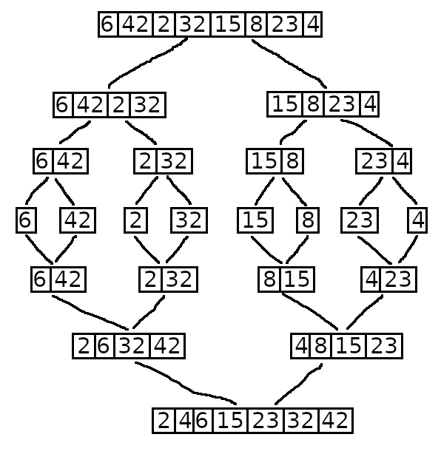
[8]

Merging
asdasdasd

Other
asdasdasd

Measuring Performance
asdasdasd

Conclusions
Asdasdasd

Bibliography
1: A. C. Sodan, J. Machina, A. Deshmeh, K. Macnaughton and B. Esbaugh, Parallelism via Multithreaded and Multicore CPUs, 2010
2: E. Lindholm, J. Nickolls, S. Oberman and J. Montrym, NVIDIA Tesla: A Unified Graphics and Computing Architecture, 2008
3: Glaskowsky, P.N., NVIDIA’s Fermi: The First CompleteGPU Computing Architecture, 2009
4: Rohit Chandra, Parallel Programmingin OpenMP, 2000
5: T. Hoshino, N. Maruyama, S. Matsuoka and R. Takaki, CUDA vs OpenACC: Performance Case Studies with Kernel Benchmarks and a Memory-Bound CFD Application.,
6: S. Farrelly, R. R. Manumachu and A. Lastovetsky, OpenH: A Novel Programming Model and API for Developing Portable Parallel Programs on Heterogeneous Hybrid Servers, 2024
7: Wen-mei W. Hwu, Izzat El Hajj, Programming Massively Parallel Processors, 2022
8: J. Lobo and S. Kuwelker, Performance Analysis of Merge Sort Algorithms, 2020

